Crisis-Time Enfranchisement and the Persistence of Protest Behaviour
BERNARD SARPONG AND JUN GOTO*

October 2025
Political protests are powerful forces for expressing grievances and demanding institutional reforms. While some individuals are consistently willing to participate in political protests, others remain reluctant despite sharing similar grievances. Yet, the sources of this heterogeneity in protest behaviour remain relatively underexplored. This study investigates whether cohorts enfranchised before the end of macroeconomic crises exhibit distinct protest behaviour compared to those enfranchised only after the crises ended. We utilise repeated cross-sectional and cross-national data to exploit variation in the timing of cohorts’ enfranchisement relative to the end of crises. The evidence suggests that the prevailing environment at the time of enfranchisement has persistent effects on citizens’ protest tendency. More precisely, citizens enfranchised during periods of macroeconomic crisis are causally more likely to engage in political protests than those enfranchised outside such periods. Further evidence suggests that this effect is driven by crisis-time enfranchisement of cohorts in the absence of imminent elections. Crisis-time enfranchisement politicises citizens in a context of widespread economic hardship and institutional distrust. In the absence of immediate formal electoral outlets, newly enfranchised citizens become increasingly exposed to intensified protest mobilisation by opposition groups, civil society, and long-enfranchised citizens seeking expedited responses to their crisis-induced grievances. Over time, this salient exposure is internalised as a learned response to political discontent, fostering a persistent tendency to engage in protest in response to subsequent grievances. This highlights the critical role of institutional timing in shaping long-term political behaviour.
Keywords: Protest Behaviour, Enfranchisement, Elections, Macroeconomic Crises
JEL: D72, E32, P16

Introduction
Political protests such as demonstrations, occupations, boycotts, and strikes are powerful expressions of citizens’ demands for institutional reforms. They often arise from perceptions of exclusion, inequality, and weak institutional accountability (Soffiantini, 2020). For example, the 2010–2012 Arab Spring uprisings were not only reactions to political repression but also to prolonged economic hardship and limited opportunities for political participation in much of the Arab world (Jones, 2012; Bayat, 2021).
The empirical literature extensively documents the proximate causes of protests throughout history. Two key factors—economic conditions and unfair political systems—have been identified as leading immediate triggers. Within this body of evidence, a large portion of studies attribute protest participation mainly to economic grievances (Dodson, 2016; Yagci, 2017; Bernburg, 2019; Kurer et al., 2019; Cristancho et al., 2019; Palmtag et al., 2020; Bremer et al., 2020; Bertuzzi et al., 2022; Azedi, 2025), while others emphasise the combined role of both economic grievances and unfair political systems (Bernburg, 2019; Bertuzzi et al., 2022). Existing theories also suggest that individuals are more likely to engage in collective action based on their perception of being worse off relative to others (Morrison, 1971; Nagel, 1974), manipulation of their beliefs by revolutionary vanguards (Bueno de Mesquita, 2010), and emotional reactions to unfair treatment (Passarelli & Tabellini, 2017).
In many instances, however, the tendency for individuals to engage in protests extends beyond immediate economic and political grievances to deeper structural conditions, particularly those shaped by macroeconomic crisis and political inclusion. These dynamics highlight a critical yet underexplored question in the academic literature: why are some individuals more predisposed to engage in protest than others despite shared grievances? Two contrasting theories underpin the discussion on the sources of protest behaviour. While the political learning theory suggests that individuals internalise and retain political orientations formed during critical periods, such as enfranchisement (i.e., gaining the right to vote) amid economic crises (Jennings & Niemi, 1974; Sears, 1983; Sears & Funk, 1999), the Threat of Revolution theory contends that extending voting rights creates institutional channels for expressing discontent, thereby diminishing the need for extra-institutional actions like protests (Acemoglu & Robinson, 2000, 2001).
To conclusively understand the heterogeneity in protest behaviour, we ask: how does enfranchisement in times of macroeconomic crises shape individuals’ long-term protest behaviour? We investigate whether cohorts enfranchised before the end of macroeconomic crises exhibit distinct protest behaviour compared to those enfranchised only after the crises ended. Understanding what accounts for the variation in individuals’ willingness to participate in political protests provides insight into human behaviour under stress, collective action problems, and the long-term effects of political and economic structures on civic engagement. Through these analyses, this study brings to light the relevance of suffrage—the most important democratic institution—in shaping individuals’ political behaviour.
To identify the persistent effect of enfranchisement in times of macroeconomic crises on protest behaviour, we exploit both between-country and within-country variation in the timing of cohorts’ enfranchisement relative to the end of crises. The main concern for our identification is omitted variable bias, arising from some unobservable factors. To mitigate this, we control for cohort, country, and survey year fixed effects as well as some relevant covariates. Controlling for these fixed effects ensures that a particular cohort, country, or time-specific factor does not drive our estimated treatment effect. The evidence from this study suggests that the prevailing environment at the time of enfranchisement has long-term consequences for citizens’ political tendency. More precisely, citizens enfranchised during periods of macroeconomic crisis are more likely to engage in political protests than those who were not enfranchised during such periods. Further evidence suggests that this effect is driven by crisis-time enfranchisement in the absence of imminent elections. Crisis-time enfranchisement heightens political salience by politicising individuals in a context of widespread hardship, perceived institutional failure, and diminished trust in governance. Given the lack of immediate elections, these newly enfranchised citizens are exposed to intensified protest mobilisation by opposition groups, civil society, and long-enfranchised citizens to demand an expedited response to their crisis-induced grievances. Over time, this salient exposure is internalised as a learned political outcome, creating a lasting tendency to substitute protest for electoral participation to express political discontent. The prime contribution of this study to the literature is that crisis-time enfranchisement in the absence of imminent elections may shape political tendencies among citizens, such as readiness to engage in protest. To the best of our knowledge, no known study has explored the causal effect of crisis-time enfranchisement exposures on the tendency of citizens to engage in protests.

Data and Empirical Strategy

Data
This study utilises the timing of enfranchisement relative to the end of crises as the treatment variable and the tendency to participate in political protests as the outcome variable. The remaining sub-sections provide a thorough definition and measurement of our key variables.

Construction of the Outcome Variable
The study relies on the merged European Values Survey (EVS) and World Values Survey (WVS) 1981-2022 datasets to construct our measure of the tendency to participate in protests. The EVS/WVS is a repeated cross-sectional and cross-national survey data on the ideas, beliefs, preferences, attitudes, values, and opinions of some 664,000 individuals from 120 countries. While the EVS contains 5 survey waves conducted every 9 years, the WVS has 7 survey waves conducted every 5 years. Within each country, the surveys are designed to be nationally representative of adults aged 18 years and older.
In this study, the outcome variable is a binary measure of the tendency of respondents to participate in political protests, specifically, participating in peaceful demonstrations. The question is posed in the survey as follows:
“Now I’d like you to look at this card. I’m going to read out some forms of political action that people can take, and I’d like you to tell me, for each one, whether you have done any of these things, whether you might do it or would never under any circumstances do it.”
The responses are initially coded as follows: 1 for “Have done,” 2 for “Might do,” and 3 for “Would never do.” To make the analysis more tractable, we generate a composite binary outcome variable by aggregating the first two alternative responses into one and recoding as: 1 for “Tendency to Protest” and 0 for “Would Never Protest.”

Construction of the Treatment Indicator
As mentioned earlier, the treatment indicator ($T_{hc}$) compares the timing of cohorts’ enfranchisement relative to the end of crises. $T_{hc}$ is calculated as the deviation of the year of enfranchisement of a birth cohort h, in country c, from the year of exposure to the end of a proximate macroeconomic crisis. Constructing the treatment variable to reflect the timing of enfranchisement relative to the end of macroeconomic crises captures the relevant exposure window during individuals’ impressionable years, when political attitudes and behaviours are most susceptible to long-term influence. Moreover, by situating the first opportunity to vote within the broader economic and political climate, the measure reflects a politically salient context in which individuals may form enduring orientations toward protest and political engagement (Jennings & Niemi, 1974; Sears, 1983; Sears & Funk, 1999). Finally, it offers a natural separation of the sample into treated and control cohorts, facilitating estimation and interpretation of treatment effects.
To understand the two components of $T_{hc}$, we first explain that a macroeconomic crisis is proxied by a severe economic recession. Following Barro and Ursúa (2008) approach, we use the peak-to-trough method to identify severe economic recession, defined as a cumulative and consecutive fractional decline in real GDP per capita of at least 10 percent. This threshold is severe enough to isolate only crises that could have an enduring effect on human behaviour. Data for identifying the cross-country crises that were not covered by Barro and Ursúa (2008) were sourced from the Maddison Project Database (2023) (Bolt & Van Zandem, 2024).
Figure 1 shows the characterisation of an episode of macroeconomic crisis in Ghana. From a peak of 7 percent growth in 1978, the Ghanaian economy declined consistently, reaching a trough in 1983; hence, 1983 marks the end of the crisis. In this example, the relevant last year of negative growth (i.e., 1983), marked by the blue vertical dashes, is regarded as the end of the crisis when determining the treatment indicator. The actual size of the contraction in the economy is about 26 percent, which meets our minimum crisis threshold of 10 percent.
[Insert Figure 1]
On the other hand, the year of enfranchisement is based on when cohorts attain the applicable voting age in their respective countries. To effectively assign country- and period-specific voting ages, we primarily rely on the EVS/WVS dataset and the history of suffrage expansion from World Population Review (2025) for the year of birth and the applicable legal voting ages of the various cohorts, respectively. It is important to emphasise that suffrage expansion has been done along two dimensions. First, from the period of limited suffrage, where the right to vote was typically restricted to certain groups based on property ownership, income, gender, race, education, or social status, inter alia, to the contemporary period of universal adult suffrage. However, we initially restrict the analysis to only the period of male-to-universal suffrage, from when only men initially had the right to vote, and then voting rights were extended to women. We later restrict the sample further to only when universal adult suffrage was achieved as a first-line robustness check. The second dimension of suffrage expansion, which remains ongoing, is the continued lowering of voting age requirements in some democracies.

Assignment of Treatment
A cohort is eligible to be treated if it was granted voting rights before the end of a macroeconomic crisis (${i.e.,T}_{hc}$ ≥ 0), while those enfranchised only after the crisis ended are the control group ($T_{hc}$ < 0). Figure 2 illustrates how the treatment indicator is constructed for two hypothetical cohorts. The hypothetical voting age in this country is 18 years. The top, middle, and bottom of the figure are labelled as “economic condition”, “treatment group”, and “control group”, respectively. Running from left to right along the middle and bottom sections, the grey shading indicates a period of “No Suffrage” whereas the deep blue shading represents “Suffrage”. The macroeconomic crisis begins when both the treatment and the control groups do not have voting rights and ends at the thick blue vertical line. However, the treatment group is enfranchised before the end of the crisis when they attain 18 years. The control group remains without voting rights until the crisis is over and they turn 18 years old.
[Insert Figure 2]

Empirical Specification
The causal effect of crisis-time enfranchisement on protest tendency is based on the following model with multiple fixed effects and clustered standard errors at the cohort-by-country level:
$$Y_{ihcs}= β{Treatment}_{hc}+λ.X_{ihc}+δ_{h}+ γ_{c}+θ_{s}+μ_{ihcs}\text{, [1]}$$
where $Y_{ihcts}$ is a binary measure of the tendency to participate protest for individual i, of birth cohort h, in country c, of survey year, s.
$$Y_{ihc}=\left\{\begin{aligned}1,Tendency to Protest \\ 0,Would Never Protest\end{aligned}\right.$$
${Treatment}_{hct}$​ is a binary treatment assignment of birth cohort h, in country c. This can be expressed in a notation as:
$${Treatmtent}_{hc}=\left\{\begin{aligned}1, if 0 ≤T_{hc} ≤4 \\ 0, if-4≤T_{hc}<0\end{aligned}\right.$$
where $T_{hc}$ is the treatment indicator, calculated as the deviation of the year of enfranchisement from the year of exposure to the end of the crisis, and $X_{ihc}$ is a vector of controls (i.e., sex and political regime). $δ_{h}$, $γ_{c}$ and $θ_{s}$ are the cohort, country, and survey year fixed effects, respectively, while $μ_{ihcs}$ captures the unobserved factors. We estimate equation [1] and all subsequent ones by ordinary least squares to provide a more direct and interpretable estimate of the causal effect.

Identification Strategy
The identification strategy relies on exploiting the variations in the timing of cohorts’ enfranchisement relative to the end of crises. We compare cohorts who gained voting rights before the end of a macroeconomic crisis with those who gained voting rights only after the crisis had ended, within the same country, c in survey year, s. Under this design, we assume that, in the absence of treatment, the protest tendency of cohorts who gained voting rights just before the end of the macroeconomic crisis (i.e., treated cohorts) would have followed the same trajectory as that of cohorts who gained voting rights just after the crisis (i.e., control cohorts). Therefore, the control cohorts serve as the counterfactual for the treated cohorts, allowing us to attribute any observed differences in protest tendency to the treatment.
Our design hinges on how narrowly we define the “exposure window” around the crisis end date. A very tight window—say, comparing cohorts enfranchised exactly one year before the crisis ended ($T_{hc}$ = –1) with those enfranchised in the year it ended ${(T}_{hc}$= 0)—would maximise internal validity on paper, but it risks misclassifying exposure in practice. Economic distress builds gradually, and most citizens cannot pinpoint the exact month when a downturn turns the corner; people gaining the vote in $T_{hc}$ = –1, 0, or +1 may perceive similar economic conditions. Conversely, a very wide window would include cohorts whose formative economic experiences differ for reasons unrelated to the focal crisis, muddying causal interpretation.
We strike a balance by restricting the analysis to cohorts whose voting-age year falls within four years on either side of the crisis end ${(T}_{hc}$ ∈ [–4, +4]). The treated cohorts ${(T}_{hc}$ ∈ [0, 4]) were clearly socialised while the economy was still contracting, whereas the control cohorts ${(T}_{hc}$ ∈ [-4, -1]) entered the electorate during the recovery phase. This ± 4-year band is narrow enough to keep age, institutional context, and long-run trends largely comparable, yet broad enough to ensure a meaningful difference in perceived macroeconomic conditions. In short, the ± 4 window minimises both misclassification of crisis exposure and confounding from unrelated cohort differences, providing the most credible comparison for our identification strategy.
The key identifying assumption underpinning the estimation of the treatment effect is the conditional mean independence: $E\left[μ_{ihcs} | {Treatment}_{hc},X_{ihc}, δ_{h},γ_{c},θ_{s}=0\right],$ conditional on observed controls $X_{ihc},$ birth cohort fixed effects $δ_{h}$, country fixed effects $γ_{c} ,$and survey year fixed effects $θ_{s}$, the unobserved factors $μ_{ihcs}$ affecting protest tendency do not systematically correlate with the ${Treattment}_{hc}.$ Technically, this implies exogeneity of the timing of enfranchisement relative to the end of macroeconomic crises. We will briefly explain how the two components of the treatment assignment support our identification. First, treatment assignment—the timing of cohorts’ enfranchisement relative to the end of the crisis—is quasi-random. The institutional determination of enfranchisement and the timing of crises are typically not coordinated. The overlap between the two is essentially driven by chance and can be explained as follows: on the one hand, the timing of cohorts’ enfranchisement is exogenously determined. Enfranchisement of cohorts is based on pre-determined legal voting age in their respective countries, which is also invariably determined by the year of birth of each cohort. This makes the timing of enfranchisement plausibly exogenous, as voting rules are not responsive to economic events. On the other hand, macroeconomic crises are considered exogenous shocks in our analysis. This is because the onset and end of crises are unanticipated and external to the actions of the cohorts in our sample. This makes the occurrence of crises independent of the unobserved factors affecting protest tendency. Relatedly, the probability of self-selection into treatment is minimised as cohorts cannot choose when they reach voting age (this is pre-determined by their year of birth and institutional rules on voting), nor can they influence when they are exposed to macroeconomic crises. Birth cohorts are thus “as if randomly assigned” to different economic contexts at the age of enfranchisement, ensuring that cohorts are less likely to self-select into treatment based on some unobserved factors that affect their protest tendency. Secondly, while potential confounding cannot be entirely ruled out, we control for a set of relevant observed covariates that are plausibly correlated with both treatment assignment and the outcome. Specifically, we control for sex and the political regime at the time of enfranchisement (1 if Democracy and 0 if otherwise) sourced from the EVS/WVS and V-Dem (2024) datasets, respectively. In combination with the other assumptions discussed, SUTVA is a necessary condition for the validity of our causal interpretation. The no-interference assumption—protest tendency of individuals is independent of others’ treatment status—is challenging to justify in studies of political behaviour. Protest actions and political attitudes are often socially transmitted through mechanisms such as peer networks, civil society mobilisation, and media discourse—dynamics that are particularly salient during periods of heightened political risk. If individuals in non-treated cohorts are influenced by treated peers, such as older siblings or friends exposed to crisis-time enfranchisement, or if protest norms diffuse across cohorts, inter-cohort interference (i.e., spillover effects) may occur. We conduct a robustness check with a narrower exposure window to limit the temporal overlap in exposure between treated and control cohorts to give some validity to the treatment effect. Again, within our identification strategy—which already absorbs cohort and country fixed effects—we add cohort-by-region (five broad regions are created which include Asia and Oceania, Europe, the Middle East and North Africa, the Americas and Sub-Saharan Africa) fixed effects to soak up region-specific shocks shared by the same birth cohort across countries, in our attempt to deal with correlated protest dynamics within geographic regions. However, since we lack direct information on protest contagion to effectively mitigate any such potential bias, any findings from this robustness check remain inconclusive.
The no-hidden-variation-in-treatment assumption in this setting implies that crisis-time enfranchisement is defined consistently across cohorts within a country. This may be violated if enfranchisement timing or eligibility criteria differ across subnational regions, demographic groups, or institutional contexts. Again, crisis severity and policy response may vary across cohorts within the same episode, which can influence their protest tendency in different ways, thereby challenging the plausibility of the SUTVA. This issue is addressed in part by estimating separate models for each broad crisis type to disaggregate the effect by crisis type.

Bias Mitigation
Although our research design and identification strategy address many threats to internal validity, omitted variable bias remains a potential concern due to unobserved heterogeneities that may confound the treatment effect. To mitigate this, we control for cohort, country, and survey-year fixed effects.
As regards unobserved cohort-specific factors, birth cohorts are likely to share certain unmeasured characteristics that may be systematically related to both treatment assignment and protest tendency. We control for cohort fixed effects to ensure that such cohort-level differences do not confound our estimated treatment effect. Similarly, individuals from the same country are likely to share common institutional, political, and cultural environments that may systematically influence both the treatment assignment and the tendency to engage in protests. If left uncontrolled, such country-level confounding could bias the estimated treatment effect. By controlling for country fixed effects, we reduce the risk that unobserved country-specific fixed factors are driving our results. Further, since we rely on all the waves of the WVS/EVS (i.e., 5 survey waves for EVS and 7 waves for WVS), it is crucial to control for survey year fixed effects to account for two sources of confounding. First, to mitigate the potential for our estimated treatment effect to be driven by a global time shock in a particular year. Again, while EVS and WVS strive for cross-wave comparability, minor changes in survey wording, administration mode, and sample design may introduce subtle biases. Survey year fixed effects account for subtle survey-wide variations across waves, which could confound the relationship between our treatment and outcome variable.
Finally, since our treatment assignment is based on cohort-by-country variation, individuals belonging to the same birth cohort from the same country are likely to share common unobserved factors that may affect the outcome variable within a cohort-by-country cluster, leading to intra-cluster correlations. This violates the “independence” part of the i.i.d. assumption and ignoring it will likely lead to underestimation of the standard errors, inflated test statistics, which increases the likelihood of a Type I error. We mitigate this by clustering the standard errors at the cohort-by-country level to ensure causal valid inference.

Discussion of Results
In Table 1, we report the summary statistics of all variables in our empirical model. Due to the absence of record-high macroeconomic crises and the restriction imposed on the treatment range to strengthen the identification of the causal effect, the final sample size was reduced to approximately 94,400 individuals from 96 countries. While the exclusion of some countries might reduce the external validity of the study by limiting generalisability, it may have little effect on—or may even enhance—internal validity, as the sample restriction improves the precision and credibility of causal inference. The proportion of treated individuals is approximately 54 percent, of which 49 percent report tending to engage in protests. Similarly, 48 percent of the respondents in the control group (i.e., untreated) intend to engage in protests in the future. This represents the baseline probability of participating in protests.
[Insert Table 1]
Further, the applicable voting ages range from 16 to 25 years, with about 63 percent of the sampled individuals enfranchised at age 18, as shown in Figure 3.
[Insert Figure 3]
In Figures 4 and 5, we also present a choropleth map and a line graph to show the geographical and time variation in protest tendency in our final sample.
[Insert Figure 4]
[Insert Figure 5]

Main Treatment Effect
Turning to our main results, the estimated treatment effects are reported in Column (2) of Table 2. We show that the prevailing environment at the time of enfranchisement has a persistent effect on citizens’ protest tendency. This is indicated by the positive coefficients of treatment, suggesting that cohorts enfranchised in times of record crises have a higher tendency to participate in political protests compared to those enfranchised only after the crises ended. In terms of magnitude, being enfranchised during a crisis increases the probability of protest participation by about 0.9 percentage points, on average. But is this economically significant within the context of this study? Given that the baseline protest intention rate is 48% among the control group (as shown in Table 1), the estimated treatment effect of 0.009 suggests that the probability of intending to protest due to the treatment is about 1.9 percent relative to the baseline protest rate. In real-world contexts where political protests are usually large in scope, even a 0.9 percentage point increase in the likelihood to protest may constitute a non-negligible and economically meaningful impact.
[Insert Table 2]
To ensure that the estimated treatment effect is not confounded by endogenous institutional transitions from male-only suffrage to universal adult suffrage, we conduct a first-line robustness check by restricting the sample to the period of universal adult suffrage. A typical example is a government that strategically extends suffrage to women during a macroeconomic crisis episode to suppress protests. In this case, the timing of enfranchisement is no longer quasi-random but endogenously determined by the crisis. Thus, treatment assignment could systematically correlate with the unmeasured factors (e.g., protest risk that influenced the decision to enfranchise) that affect long-term protest tendency, causing institutional-level confounding. By restricting the sample to the universal suffrage period, we are more likely to estimate the treatment effect under a more uniform institutional context. The resulting estimates are reported in Column (2) of Table 2. The results affirm that the estimated treatment effect persists even when all individuals, regardless of sex, have equal formal voting rights. Additionally, we report the insignificant estimates from the narrower treatment windows in Tables A1–A3 of the Appendix, although we do not rely on them as explained earlier in the identification strategy.
To better understand which component of the composite outcome is driving the observed treatment effect, we conducted a decomposition analysis by separating the outcome into its original categories. Specifically, we estimate treatment effects on two distinct binary outcomes: (1) whether an individual has engaged in protest behaviour (Have done) versus those who report they would never do so, and (2) whether an individual expresses a willingness to engage in protest in the future (Might do) versus those who indicate they would never participate. The results of this outcome decomposition analysis are reported in Table A4 of the Appendix. We find that the observed treatment effect of crisis-time enfranchisement is primarily concentrated among cohorts who report a willingness to protest in the future, rather than among those who have already done so. This suggests that crisis-time enfranchisement may shape readiness to engage in protest rather than immediately resulting in protest behaviour. We interpret this as evidence of latent protest potential rather than a lack of behavioural impact. Actual protest participation is often constrained by external conditions such as political repression, lack of mobilisation, or opportunity structure, especially in non-democratic. Therefore, willingness to protest can still be a meaningful indicator of political engagement and remains a valid behavioural outcome, especially when viewed as a necessary signal of collective action.

Robustness Checks
Beyond restricting the analysis to only when universal adult suffrage was achieved as a first-line robustness check, we subject the results in Table 2 to an additional robustness check by restricting the range of treatment to $-3≤ T_{hc} ≤3$. As shown in Table 3, a tighter range of treatment has a negligible impact on the baseline evidence in Table 2.
[Insert Table 3]
To address any concerns about correlated protests across countries—which could lead to spillover effects, such as learning from treated respondents to the control cohort and thereby biasing the estimation of the treatment effect—we explore an alternative specification by controlling for cohort-by-region fixed effects (five broad regions including, Asia and Oceania, Europe, the Middle East and North Africa, the Americas, and Sub-Saharan Africa). This interaction fixed effects term controls for unobserved common shocks, such as protest contagion and political waves, to countries in the same region for a given cohort, which can partially soak up cross-country protest correlation. We report these results in Table A5 of the Appendix. The treatment effect is closer to zero and loses statistical significance in the specification with cohort-by-region fixed effects, likely because regional cohort-specific shocks, such as protest contagion, drive the baseline estimate. The cohort-by-region fixed effects appear to absorb part of this contagion. However, it is important to emphasise that this finding is not conclusive, as we lack direct information on protest contagion to address this potential bias econometrically.
In a further robustness check, we confirm whether the underlying causes of the macroeconomic crisis matter in identifying the causal effects by conducting sub-sample analyses. We avoid relying on subjective or arbitrary criteria when identifying the underlying causes of the crisis, instead using the clear and consistent definitions established by Barro and Ursúa (2008). They categorise crises as follows: (i) wars on one’s own soil, (ii) wars on foreign soil, (iii) civil wars, and (iv) changed economic relationships with the former Soviet Union. Based on this, we distinguish between three broad causes of macroeconomic crisis: war-related (i.e., World War I, World War II, coups d’état, civil wars, interstate wars, and other armed conflicts); post-communist dissolutions referring to the collapse of the Soviet Union, and the breakups of Yugoslavia and Czechoslovakia; and other factors (i.e., the remaining crisis episodes after excluding the war-related and post-communist dissolution categories). The results reported in Tables 4, 5, and 6 show that the type of crisis plays an important role in shaping the long-term protest tendency of citizens who gained voting rights in times of crisis. In particular, in crises driven by war or conflict, we observe a negative treatment effect as shown in Table 4: cohorts who were enfranchised before the end of the crisis are less likely to protest than those who were not. This may reflect the unique political dynamics of wartime crises, where security concerns and national solidarity tend to discourage opposition and encourage loyalty to the state. For the post-communist dissolution-related macroeconomic declines, we do not find any meaningful effect regardless of the model specification in Table 5. By contrast, we find that when crises are caused by other factors not related to war or regime collapse, crisis-time enfranchised cohorts are more predisposed to engage in protest, as reported in Table 6.
The crisis-type heterogeneity analysis makes it evident that the observed effect in the full sample is not likely to be primarily driven by enfranchisement in times of war or regime collapse-related crises. Another important observation is the robustness of the estimated effect in all specifications for each underlying cause of crisis. The sub-sample findings highlight meaningful heterogeneity in how different crisis contexts condition the behavioural consequences of political inclusion.
[Insert Table 4]
[Insert Table 5]
[Insert Table 6]

Falsification Tests
Despite our robust estimation strategy to mitigate any potential bias in estimating the treatment effect, we conduct a series of falsification tests to assess the validity of our identification strategy. We define several falsification groups—cohorts for whom no treatment effect should arise based on institutional or historical contexts—to test the credibility of our identification strategy. Thus, we do not expect to observe any significant effects of pseudo-treatments on protest tendency. Two groups are broadly categorised based on our dataset for this analysis.

Traditional Placebo Groups
The traditional placebo groups consist of the remaining cohorts who would have otherwise qualified for treatment but, due to the absence of universal adult suffrage at the time, were not exposed to our treatment. We verify that our identification strategy is not falsely detecting treatment effects in cohorts affected by “Pre-Universal Suffrage”. These are both men and women who had no voting rights because they came of age before the introduction of universal suffrage in their respective jurisdictions. We initially conduct a separate placebo test for only the women who lacked voting rights during periods of male-only suffrage (they are assigned the existing male voting age) and later extend it to cohorts (i.e., both men and women) who came of age during pre-suffrage (they are assigned the applicable voting age at initial suffrage). The following model is estimated for these groups:
$$Y_{ihcs}= β{.Placebo.Treatment}_{hc}+λ.X_{ihc}+δ_{h}+ γ_{c}+θ_{s}+μ_{ihcs}\text{, [}\text{2}\text{]}$$
where ${Placebo.Treatment}_{hc}$​ is the binary placebo treatment assignment of birth cohort h, in country c.
${Placebo.Treatmtent}_{hc}=\left\{\begin{aligned}1, if 0 ≤T_{hc} ≤4 \\ 0, if-4≤T_{hc}<0\end{aligned}\right.$
All other variables retain their definitions in Equation [1].

Pseudo-Treatment Groups
Within this category, we first conduct a falsification test for cohorts in countries with no history of macroeconomic crisis. For these cohorts, we assigned regional or global economic crises, with a pseudo treatment defined as:
$${Pseudo.Treatmtent}_{hc}=\left\{\begin{aligned}1, if 0 ≤T_{hc} ≤4 \\ 0, if-4≤T_{hc}<0\end{aligned}\right.$$
Next, we test for any spurious treatment effects in cohorts who have had no exposure to any macroeconomic crises since birth, despite residing in countries with a history of crises (i.e., $-87≤T_{hc}≤-17$). Further, we check for any false treatment effects within the main treatment (i.e., $0≤T_{hc}≤4$) and control groups (i.e., $-4≤T_{hc}≤-1$). We conclude with the extreme cases of children exposed to crises several years before (typically at the ages of 0 to 10 years) enfranchisement (within the treatment range $-24≤T_{hc}≤-15$) and older cohorts exposed to crises several years after (typically at the ages of 73 to 120 years) enfranchisement (within the treatment range $55≤T_{hc}≤99$). As indicated in parentheses, the values of the treatment indicator for these groups do not coincide with the actual range of treatment assignment, hence, we assign pseudo treatments by shifting cut-offs as given by the operator below:
$${Pseudo.Treatmtent}_{hc}=\left\{\begin{aligned}1, if pseudo cutoff≥25th, 50th and 75th percentile \\ 0,if pseudo cutoff<25th, 50th and 75th percentile\end{aligned}\right.$$
The results of the traditional placebo tests are reported in Table 7, and those of the pseudo-treatments, in Tables A6–A10 of the Appendix. In both Columns (1) and (2) of Table 7, no effects are detected. Similarly, the pseudo-treatment effects are largely insignificant in Tables A6–A10, which validates that our estimated treatment effect is not likely to be driven by any confounder.
[Insert Table 7]

Salience of Crisis-Time Enfranchisement
When cohorts are enfranchised during periods of macroeconomic crisis, their initial exposure to political participation occurs in a context marked by widespread hardship, perceived institutional failure, and diminished trust in governance. Within such environments, enfranchisement may generate unintended consequences, including the development of a latent readiness to engage in protest that persists over time. Two related factors interact to render this exposure particularly salient in shaping the protest tendency of these cohorts.
First, enfranchisement is associated with a heightened sense of political agency. Enfranchisement fosters a sense of political legitimacy among recipients, enhancing their perceived role as active participants in the political system. This, in turn, motivates them to seek information necessary to navigate their new civic responsibilities, make informed decisions, and evaluate the responsiveness of political institutions. This enables newly enfranchised cohorts to understand what accountable governance entails and equips them to assess and respond when institutions fail. Consequently, they come to understand that local economic crises (e.g., state or national) result from institutional failure on the part of political actors responsible for managing and safeguarding economic stability. Relatedly, local economic crises often trigger increased mobilisation efforts by opposition groups, civil society, and the media to demand redistribution and structural change. Even if the newly enfranchised cohorts do not immediately engage in these crisis-induced protests, this initial exposure to protest-prone environments serves as a lasting reference point that shapes their orientation toward grievance expression. Protest, in this context, becomes a learned response to political discontent; over time, this salient exposure increases the tendency of such cohorts to engage in protest. However, cohorts without voting rights are less likely to seek such information and, consequently, may be less aware of institutional responsibilities, thus reducing the likelihood of developing grievances related to governance or accountability.
The persistence of learned protest tendency is partly attributable to the age at which treated cohorts were enfranchised—between 16 and 25—an age window widely recognised as the impressionable years, during which individuals form enduring attitudes, beliefs, and preferences. Exposure to salient political experiences during this critical period increases susceptibility to lasting political socialisation. As a result, these cohorts may exhibit greater tendencies to protest because the timing of their political inclusion has fundamentally shaped their understanding of political empowerment and civic expression.

Mechanism Underpinning the Treatment Effect
The purpose of granting voting rights is to enable individuals to participate in elections. Thus, to understand the underlying mechanism that drives the observed treatment effect, we test whether the significance of the timing of future elections relative to enfranchisement. This is modelled as an interaction between the treatment and binary future election indicator (sourced from Döring & Düpont, 2020) as follows:
$$Y_{ihcs}= β{.Treatment}_{hc}+ϕ.{[Treatment × No Elections]}_{hc}+λ.X_{ihc}+ δ_{h}+ γ_{c}+θ_{s}+μ_{ihcs}\text{, [}\text{3}\text{]}$$
where ${[Treatment × No Elections]}_{hc}$ is the interaction between the treatment and the indicator of imminent elections after enfranchisement. ${No Elections}_{hc}$is a binary indicator for the timing of future elections relative to the enfranchisement of birth cohort h, in country c.
$${No Elections}_{hc}=\left\{\begin{aligned}1, if future elections-year of enfranchisement>1 year \\ 0, if future elections-year of enfranchisement≤1 year\end{aligned}\right.$$
All other variables retain their definitions in Equation [1]. The results of the interaction term, reported in Columns (1) and (2) of Table 8, indicate a positive and significant treatment effect, implying that cohorts granted suffrage without immediate elections in times of crisis are more likely to engage in protests, supporting the protest-mobilising effect of suffrage expansion. In terms of magnitude, this translates to a 1.4 percentage point increase in the probability of protesting. This suggests that being able to exercise the political franchise holds greater significance for citizens than merely possessing that right. It is also evident from Columns (1) and (2) of Table 8 that when elections are held soon after enfranchisement (i.e., within a year), there is no statistically significant difference in the protest tendency between the treated and control groups.
[Insert Table 8]
We conduct a split-sample analysis based on the binary indicator of “no elections” to assess the consistency of the heterogeneity results. As reported in Table 9, the findings remain robust across the split-sample based on the timing of elections after crisis-time enfranchisement.
[Insert Table 9]
Our findings on the timing of future elections relative to enfranchisement are very instructive. The absence of elections in times of crisis intensifies the mobilisation of protests by opposition groups, civil society, and the long-enfranchised citizens to demand an expedited response to the widespread economic hardship. This is because citizens have limited effective institutional channels to express their crisis-induced grievances; thus, protest becomes the best alternative. Exposure to such a protest-prone environment by newly enfranchised citizens further socialises them to view protest as a legitimate and effective tool in demanding accountability from the ruling government. Over time, this exposure is internalised as a learned political behaviour, creating a persistent tendency to engage in protests in the wake of any future grievances.
By contrast, institutional learning through immediate exposure to elections after enfranchisement may foster protest aversion by providing newly enfranchised cohorts with a legitimate and institutionalised avenue for expressing political preferences and addressing collective grievances. The prompt exercise of the political franchise leads cohorts to internalise the belief that they can influence outcomes through formal mechanisms rather than contentious actions—the protest-resignation effect of suffrage expansion. Furthermore, early exposure to electoral processes helps normalise voting as the primary mode of political engagement. Over time, this form of institutional learning socialises individuals into constructive and system-oriented political behaviours, reducing their propensity to engage in protests.
Overall, the evidence supports our prediction derived from the political learning theory that suffrage expansion leads to an increased tendency to participate in protest among newly enfranchised groups.

Conclusion
The literature is replete with evidence on the immediate triggers of protests, but offers limited insight into why some individuals are more predisposed to protest than others. Consequently, this study investigates the sources of variation in protest behaviour by assessing whether cohorts enfranchised before the end of macroeconomic crises differ in their tendency to protest compared to those enfranchised after such crises had ended. Drawing on original evidence, the study finds that the economic and political context at the time of enfranchisement exerts a lasting influence on political behaviour. Specifically, individuals who gain voting rights during periods of severe economic crisis are more likely to engage in protest than those without voting rights during such periods. This evidence is driven by cohorts enfranchised in times of no imminent elections. Crisis-time enfranchisement heightens political salience as individuals’ initial political exposure occurs in an environment marked by crisis-induced hardship and institutional distrust. In the absence of immediate electoral outlets, newly enfranchised cohorts are exposed to disproportionate protest activity by long-enfranchised citizens to demand an expedited response to their crisis-imposed hardships. Over time, this early exposure is internalised as a learned response to political discontent, fostering a lasting tendency to express grievances through protest rather than voting.
Although we made some attempts to address confounding from protest correlation across countries, we lack direct information on protest contagion to effectively mitigate spillover effects. Future research should seek to address this limitation by exploring richer datasets with detailed protest histories of cohorts to broaden our knowledge of the sources of heterogeneity in this behavioural disposition.

Table 1: Summary Statistics
Variable | Full Sample |  | Treatment |  | Control
Observations | 94,416 |  | 51,271 |  | 43,145
Protests (%)
Tendency to Protest | 48.6 |  | 49.3 |  | 47.7
Would Never Protest | 51.4 |  | 50.7 |  | 52.2
No Election (%)
More than a year | 47.1 |  | 46.0 |  | 47.1
Within a year | 52.9 |  | 54.0 |  | 52.9
Sex (%)
Female | 51.2 |  | 51.3 |  | 51.1
Male | 48.8 |  | 48.7 |  | 48.9
Political Regime (%)
Democracy | 47.1 |  | 41.3 |  | 54.1
Non-Democracy | 52.9 |  | 58.8 |  | 45.9
Notes: The summary statistics are based on the observations used in generating the baseline estimates. Protest is a binary measure of the tendency to participate in protests (1 if cohorts have the tendency to engage in protests and 0 if they would never do so). No elections takes the value 1 if no election occurs within a year of enfranchisement, and 0 if an election does. Sex (1 if Female, 0 if Male) and political regime (1 if Electoral Democracy, 0 if Non-democracy).

Table 2: Estimated Effect of Treatment on Protest Tendency
 |  | (1) | (2)
Variables | Male-to-Universal Suffrage |  | Universal Suffrage
Treatment = 1 | 0.009**  (0.004) |  | 0.009*  (0.004)
Observations | 94,414  96  ✓  ✓  ✓  ✓ |  | 92,570  94  ✓  ✓  ✓  ✓
No. of Countries
Controls
Cohort FE
Country FE
Survey Year FE
Notes: This table reports regression results of the binary treatment indicator based on a treatment range $-4≤ T_{hc} ≤4$. Cohorts with treatment range $0 ≤T_{hc} ≤4$are assigned a treatment value of 1, whereas those within $-4≤T_{hc}<0$are assigned 0. The outcome variable is also a binary measure of the tendency to participate in protests (1 if cohorts have the tendency to engage in protests and 0 if they would never do so). Column (1) uses the full sample of the male-to-universal suffrage period: the cohorts came of age starting from when only men initially had the right to vote and later extended to women. In Column (2), the sample is restricted to only when universal adult suffrage was achieved to serve as a first-line robustness check. In all specifications, we control for sex (1 if Female, 0 if Male) and political regime (1 if Electoral Democracy, 0 if Non-democracy), as well as cohort, country, and survey year fixed effects. Standard errors clustered at the cohort-by-country level are reported in parentheses. Significance levels: *** p<0.01, ** p<0.05, * p<0.1.

Table 3: Robustness Check for the Treatment Effect
 |  | (1) | (2)
Variables | Male-to-Universal Suffrage |  | Universal Suffrage
Treatment = 1 | 0.009**  (0.005) |  | 0.008*  (0.005)
Observations | 75,633  96  ✓  ✓  ✓  ✓ |  | 74,134  94  ✓  ✓  ✓  ✓
No. of Countries
Controls
Cohort FE
Country FE
Survey Year FE
Notes: This table reports regression results of the binary treatment indicator based on a tight treatment range $-3≤ T_{hc} ≤3$. Cohorts with treatment range $0 ≤T_{hc} ≤3$are assigned a treatment value of 1, whereas those within $-3≤T_{hc}<0$are assigned 0. The outcome variable is also a binary measure of the tendency to participate in protests (1 if cohorts have the tendency to engage in protests and 0 if they would never do so). Column (1) uses the full sample of the male-to-universal suffrage period: the cohorts came of age starting from when only men initially had the right to vote and later extended to women. In Column (2), the sample is restricted to only when universal adult suffrage was achieved to serve as a first-line robustness check. In all specifications, we control for sex (1 if Female, 0 if Male) and political regime (1 if Electoral Democracy, 0 if Non-democracy), as well as cohort, country, and survey year fixed effects. Standard errors clustered at the cohort-by-country level are reported in parentheses. Significance levels: *** p<0.01, ** p<0.05, * p<0.1.

Table 4: Robustness Checks for the Treatment Effect: War-Related
 | (1) | (2) |  | (3) | (4)
Variable | Male-to-Universal Suffrage |  |  | Universal Suffrage
Treatment = 1 | -0.017**  (0.008) |  | -0.034**  (0.014) | -0.023***  (0.009) |  | -0.042***  (0.014)
Observations | 18,159 |  | 18,152 | 17,048 |  | 17,045
No. of Countries | 47 |  | 47 | 43 |  | 43
Controls | ✓ |  | ✓ | ✓ |  | ✓
Cohort FE | ✓ |  | ✓ | ✓ |  | ✓
Country FE | ✓ |  | ✓ | ✓ |  | ✓
Survey Year FE | ✓ |  | ✓ | ✓ |  | ✓
Cohort X Region FE | X |  | ✓ | X |  | ✓
Notes: This table reports regression results of a sub-sample analysis on macroeconomic declines caused by war-related (i.e., World War I, World War II, coups d’état, civil wars, interstate wars, and other armed conflicts). The treatment is binary, where cohorts with treatment indicator value within $0 ≤T_{hc} ≤4$are assigned 1 and those within $-4≤T_{hc}<0$are assigned 0. The outcome variable is also a binary measure of the tendency to participate in protests (1 if cohorts have the tendency to engage in protests and 0 if they would never do so). Column (1) uses the full sample of the male-to-universal suffrage period: the cohorts came of age starting from when only men initially had the right to vote and later extended to women. In Column (2), the sample is restricted to only when universal adult suffrage was achieved to serve as a first-line robustness check. In all specifications, we control for sex (1 if Female, 0 if Male) and political regime (1 if Electoral Democracy, 0 if Non-democracy), as well as cohort, country, and survey year fixed effects. Standard errors clustered at the cohort-by-country level are reported in parentheses. Significance levels: *** p<0.01, ** p<0.05, * p<0.1.

Table 5: Robustness Checks for the Treatment Effect: Post-Communist Dissolutions
 | (1) | (2) |  | (3) | (4)
Variable | Male-to-Universal Suffrage |  |  | Universal Suffrage
Treatment = 1 | 0.003  (0.013) |  | 0.005  (0.013) | 0.003  (0.013) |  | 0.005  (0.013)
Observations | 22,766 |  | 22,766 | 22,766 |  | 22,766
No. of Countries | 29 |  | 29 | 29 |  | 29
Controls | ✓ |  | ✓ | ✓ |  | ✓
Cohort FE | ✓ |  | ✓ | ✓ |  | ✓
Country FE | ✓ |  | ✓ | ✓ |  | ✓
Survey Year FE | ✓ |  | ✓ | ✓ |  | ✓
Cohort X Region FE | X |  | ✓ | X |  | ✓
Notes: This table reports regression results of a sub-sample analysis on macroeconomic declines caused by post-communist dissolutions (i.e., the collapse of the Soviet Union, as well as the breakups of Yugoslavia and Czechoslovakia). The treatment is binary, where cohorts with treatment indicator value within $0 ≤T_{hc} ≤4$are assigned 1 and those within $-4≤T_{hc}<0$are assigned 0. The outcome variable is also a binary measure of the tendency to participate in protests (1 if cohorts have the tendency to engage in protests and 0 if they would never do so). Column (1) uses the full sample of the male-to-universal suffrage period: the cohorts came of age starting from when only men initially had the right to vote and later extended to women. In Column (2), the sample is restricted to only when universal adult suffrage was achieved to serve as a first-line robustness check. In all specifications, we control for sex (1 if Female, 0 if Male) and political regime (1 if Electoral Democracy, 0 if Non-democracy), as well as cohort, country, and survey year fixed effects. Standard errors clustered at the cohort-by-country level are reported in parentheses. Significance levels: *** p<0.01, ** p<0.05, * p<0.1.

Table 6: Robustness Checks for the Treatment Effect: Other Factors
 | (1) | (2) |  | (3) | (4)
Variable | Male-to-Universal Suffrage |  |  | Universal Suffrage
Treatment = 1 | 0.017***  (0.004) |  | 0.018**  (0.006) | 0.017***  (0.005) |  | 0.019***  (0.006)
Observations | 53,486 |  | 53,475 | 52,754 |  | 52,748
No. of Countries | 65 |  | 65 | 63 |  | 63
Controls | ✓ |  | ✓ | ✓ |  | ✓
Cohort FE | ✓ |  | ✓ | ✓ |  | ✓
Country FE | ✓ |  | ✓ | ✓ |  | ✓
Survey Year FE | ✓ |  | ✓ | ✓ |  | ✓
Cohort X Region FE | X |  | ✓ | X |  | ✓
Notes: This table reports regression results of a sub-sample analysis on macroeconomic declines caused by other factors (i.e., the remaining crisis episodes after excluding the war-related and post-communism dissolution categories). The treatment is binary, where cohorts with treatment indicator value within $0 ≤T_{hc} ≤4$are assigned 1 and those within $-4≤T_{hc}<0$are assigned 0. The outcome variable is also a binary measure of the tendency to participate in protests (1 if cohorts have the tendency to engage in protests and 0 if they would never do so). Column (1) uses the full sample of the male-to-universal suffrage period: the cohorts came of age starting from when only men initially had the right to vote and later extended to women. In Column (2), the sample is restricted to only when universal adult suffrage was achieved to serve as a first-line robustness check. In all specifications, we control for sex (1 if Female, 0 if Male) and political regime (1 if Electoral Democracy, 0 if Non-democracy), as well as cohort, country, and survey year fixed effects. Standard errors clustered at the cohort-by-country level are reported in parentheses. Significance levels: *** p<0.01, ** p<0.05, * p<0.1.

Table 7: Results of Traditional Placebo Tests
 | (1) | (2)
Variables | Gendered Suffrage | Pre-Universal Suffrage
Placebo-Treatment = 1 | 0.029  (0.027) | 0.009  (0.011)
Observations | 2,134  20  ✓  ✓  ✓  ✓ | 7,264  42  ✓  ✓  ✓  ✓
No. of Countries
Controls
Cohort FE
Country FE
Survey Year FE
Notes: This table reports regression results of the binary placebo treatments. The placebo treatment range is $-4≤ T_{hc} ≤4$. Cohorts with treatment range $0 ≤T_{hc} ≤4$are assigned a treatment value of 1, whereas those within $-4≤T_{hc}<0$are assigned 0. The outcome variable is also a binary measure of the tendency to participate in protests (1 if cohorts have the tendency to engage in protests and 0 if they would never do so). Column (1) reports the placebo test for only the women who lacked voting rights during periods of male-only suffrage (they are assigned the existing male voting age). Column (2) extends the placebo group used in Column (1) to include both men and women who did not have voting rights because they came of age before the introduction of universal suffrage in their respective jurisdictions (they are assigned the applicable voting age at initial suffrage). In all specifications, we control for sex (1 if Female, 0 if Male) and political regime (1 if Electoral Democracy, 0 if Non-democracy) as well as cohort, country, and survey year fixed effects. Standard errors clustered at the cohort-by-country level are reported in parentheses. Significance levels: *** p<0.01, ** p<0.05, * p<0.1.

Table 8: Mechanism Underpinning the Treatment Effect
 |  | (1) | (2)
Variables | Male-to-Universal Suffrage |  | Universal Suffrage
Treatment = 1 | 0.003  (0.006) |  | 0.002  (0.006)
Treatment x No Elections | 0.014*  (0.008) |  | 0.013*  (0.008)
No Election = 1 | -0.010  (0.006) |  | -0.009  (0.006)
Observations | 94,414  96  ✓  ✓  ✓  ✓ |  | 92,570  94  ✓  ✓  ✓  ✓
No. of Countries
Controls
Cohort FE
Country FE
Survey Year FE
Notes: This table reports regression results of the binary treatment indicator based on a treatment range $-4≤ T_{hc} ≤4$. Cohorts with treatment range $0 ≤T_{hct} ≤4$are assigned a treatment value of 1, whereas those within $-4≤T_{hc}<0$are assigned 0. (Treatment x No Elections) is the interaction between the treatment and future elections after enfranchisement. “No elections” takes the value 1 if no election occurs within a year of enfranchisement, and 0 if an election does. The outcome variable is also a binary measure of the tendency to participate in protests (1 if cohorts have the tendency to engage in protests and 0 if they would never do so). Column (1) uses the full sample of the male-to-universal suffrage period: the cohorts came of age starting from when only men initially had the right to vote and later extended to women. In Column (2), the sample is restricted to only when universal adult suffrage was achieved to serve as a first-line robustness check. In all specifications, we control for sex (1 if Female, 0 if Male) and political regime (1 if Electoral Democracy, 0 if Non-democracy), as well as cohort, country, and survey year fixed effects. Standard errors clustered at the cohort-by-country level are reported in parentheses. Significance levels: *** p<0.01, ** p<0.05, * p<0.1.

Table 9: Split-Sample of Mechanism Underpinning the Treatment Effect
 | (1) | (2) |  | (3) | (4)
Variable | Male-to-Universal Suffrage |  |  | Universal Suffrage
 | Elections |  | No Elections | Elections |  | No Elections
Treatment = 1 | 0.004  (0.007) |  | 0.016***  (0.006) | 0.004  (0.007) |  | 0.015***  (0.006)
Observations | 49,935 |  | 44,476 | 49,207 |  | 43,358
No. of Countries | 94 |  | 95 | 92 |  | 93
Controls | ✓ |  | ✓ | ✓ |  | ✓
Cohort FE | ✓ |  | ✓ | ✓ |  | ✓
Country FE | ✓ |  | ✓ | ✓ |  | ✓
Survey Year FE | ✓ |  | ✓ | ✓ |  | ✓
Notes: This table reports regression results of a split-sample analysis based on the binary indicator of “no elections”. Columns with sub-heading “elections” are estimates for cohorts with future elections occurring after more than a year of enfranchisement. Conversely, columns with sub-heading “no elections” are estimates for cohorts with no elections occurring within a year of enfranchisement. Treatment is a binary variable based on treatment indicator values $-4≤ T_{hc} ≤4$. Cohorts with treatment range $0 ≤T_{hc} ≤4$are assigned a treatment value of 1, whereas those within $-4≤T_{hc}<0$are assigned 0. The outcome variable is also a binary measure of the tendency to participate in protests (1 if cohorts have the tendency to engage in protests and 0 if they would never do so). Columns (1) and (2) use the sample for the male-to-universal suffrage period: the cohorts came of age starting from when only men initially had the right to vote and later extended to women. In Columns (3) and (4), the sample is restricted to only when universal adult suffrage was achieved to serve as a first-line robustness check. In all specifications, we control for sex (1 if Female, 0 if Male) and political regime (1 if Electoral Democracy, 0 if Non-democracy), as well as cohort, country, and survey year fixed effects. Standard errors clustered at the cohort-by-country level are reported in parentheses. Significance levels: *** p<0.01, ** p<0.05, * p<0.1.

Figure 1: Characterising Macroeconomic Crisis
End of Crisis
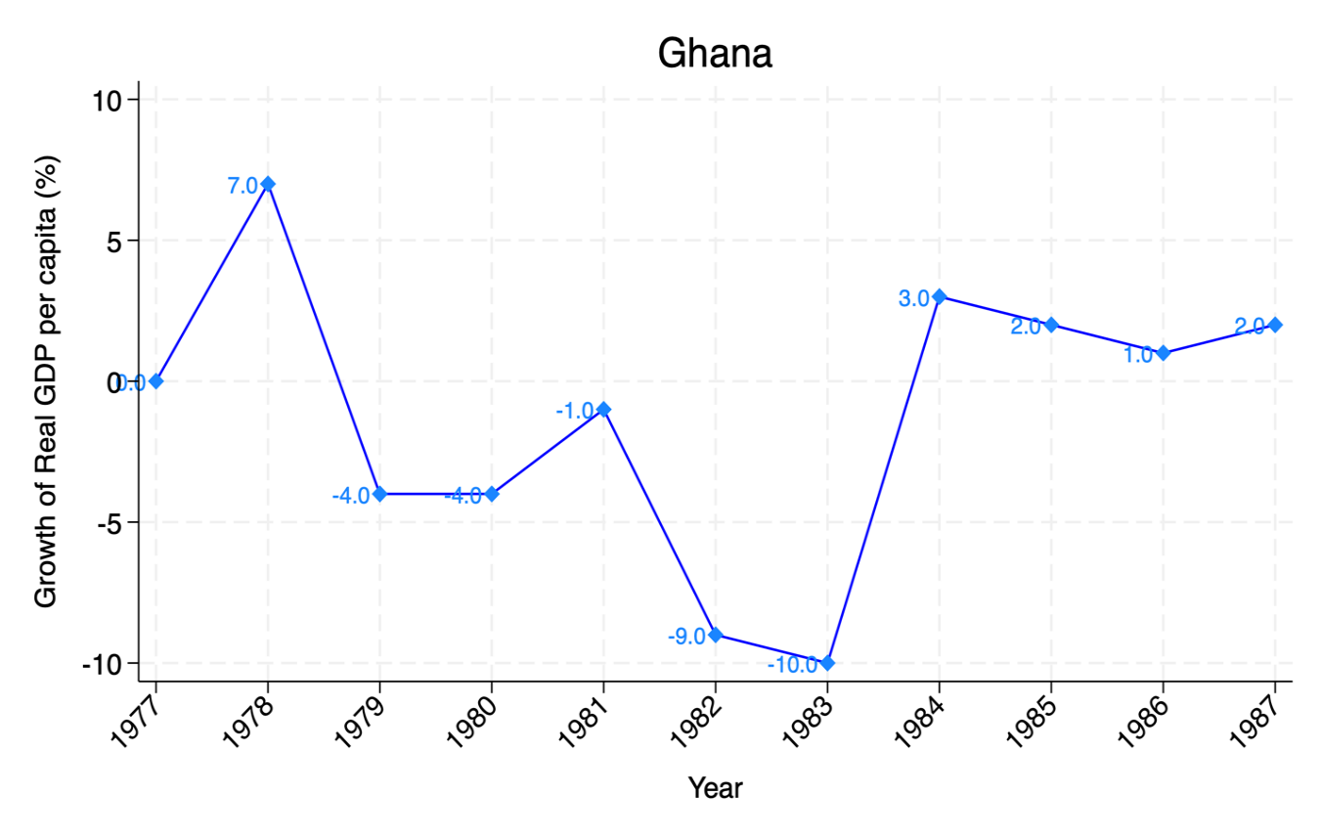
Notes: This is a classic example of a macroeconomic crisis episode in Ghana. The peak and the trough of the crisis are the years 1978 and 1983, respectively; hence, the year 1983 marks the end of the crisis.
Source: Authors’ illustration based on the Maddison Project Database (2023)

Figure 2: Construction of the Treatment Indicator
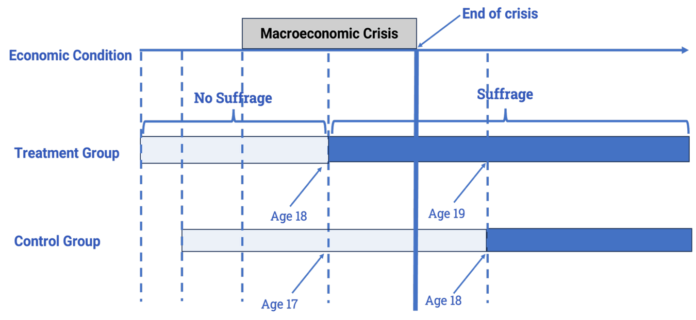
Notes: The top, middle, and bottom of the figure are labelled as economic condition, treatment group, and control group, respectively. The hypothetical voting age in this figure is 18 years. Running from left to right along the middle and bottom sections, the grey shading indicates a period of “No Suffrage” whereas the deep blue shading represents “Suffrage”. The crisis begins when both the treatment and the control groups do not have voting rights and ends at the thick blue vertical line. On the blue vertical dashes just before the crisis-end line, the treatment group is enfranchised before the end of the crisis when they attain 18 years. The control group attains the voting age of 18 years only after the crisis is over, marked by the blue vertical dashes after the crisis-end line.
Source: Authors’ illustration

Figure 3: Voting Age Distribution in the Sample
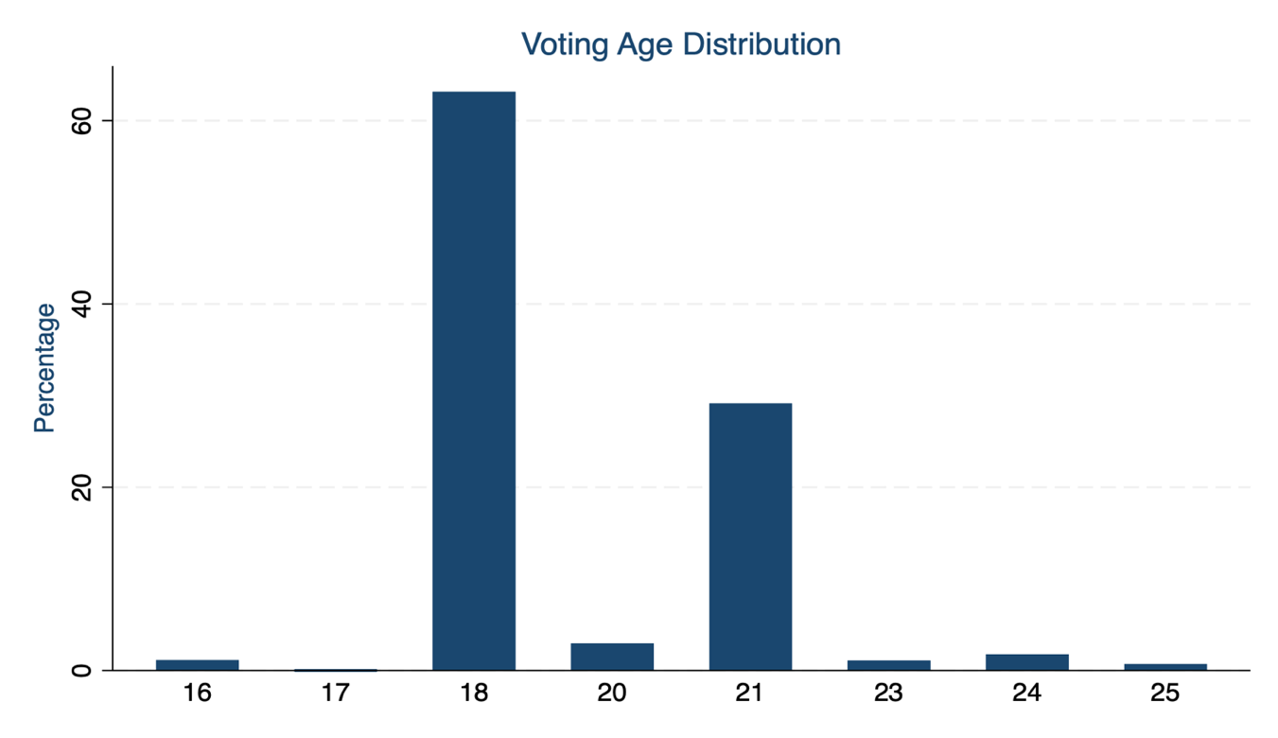Source: Authors’ illustration using data from World Population Review (2025)
Figure 4: Geographical Variation in Protest Tendency
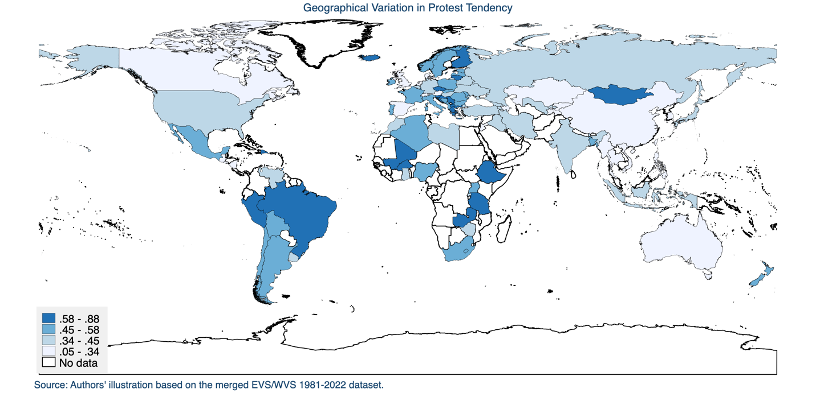

Figure 5: Time Variation in Protest Tendency
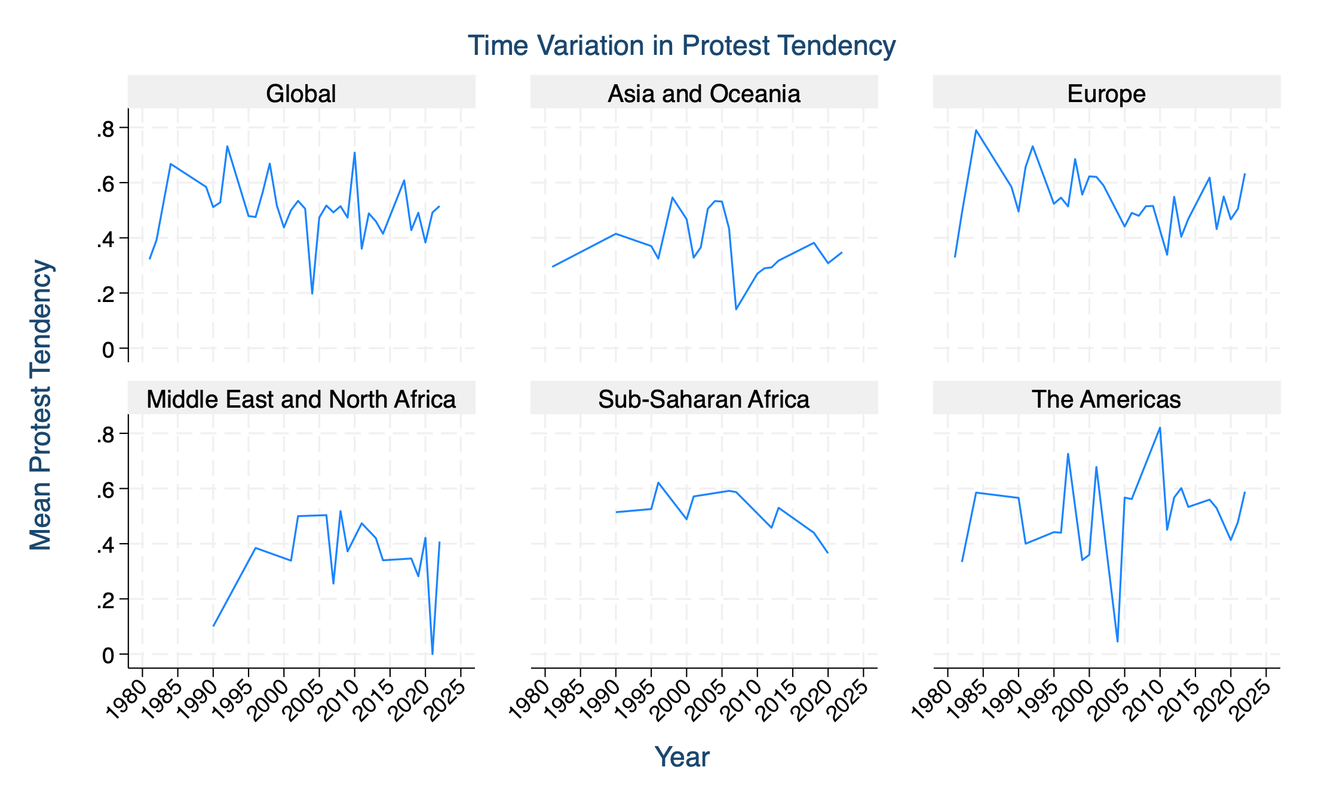
Source: Authors’ illustration based on the merged EVS/WVS 1981-2022 Dataset

References
Acemoglu, D., & Robinson, J. A. (2000). Why did the West extend the franchise? Democracy, inequality, and growth in historical perspective. The quarterly journal of economics, 115(4), 1167-1199.
Acemoglu, D., & Robinson, J. A. (2001). A theory of political transitions. American Economic Review, 91(4), 938-963.
Azedi, A. (2025). From shared grievances to collective action: A multilevel study of economic adversity and protest. International Sociology, 40(1), 3-32.
Barro, R. J., & Ursúa, J. F. (2008). Macroeconomic Crises since 1870. Brookings Papers on Economic Activity, 2008(1), 255-350.
Bayat, A. (2021). The Arab Spring and revolutionary theory: An intervention in a debate. Journal of Historical Sociology, 34(2), 393-400.
Bernburg, J. G. (2019). The cascading crisis and the changing base of popular protest: The case of Iceland. Current Sociology, 67(7), 1018-1038.
Bertuzzi, N., Chironi, D., Della Porta, D., Milan, C., Portos, M., & Zamponi, L. (2022). Bringing grievances back in? Socio-economic inequalities and the political participation of protesters. In Resisting the Backlash (pp. 27-55). Routledge.
Bolt, J., & Van Zanden, J. L. (2024). Maddison‐style estimates of the evolution of the world economy: A new 2023 update. Journal of Economic Surveys, 1–41. Retrieved June 29, 2024, from https://doi.org/10.1111/joes.12618
Brancati, D. (2014). Pocketbook protests: Explaining the emergence of pro-democracy protests worldwide. Comparative Political Studies, 47(11), 1503-1530.
Brancati D. (2016). Relating Economic Crises to Democracy. In: Democracy Protests: Origins, Features, and Significance, 39-60, Cambridge University Press.
Bremer, B., Hutter, S., & Kriesi, H. (2020). Dynamics of protest and electoral politics in the Great Recession. European Journal of Political Research, 59(4), 842-866.
Burlinson, A., Giulietti, M., Law, C., & Liu, H. H. (2021). Fuel poverty and financial distress. Energy economics, 102, 105464.
Cantoni, D., Yang, D. Y., Yuchtman, N., & Zhang, Y. J. (2019). Protests as strategic games: experimental evidence from Hong Kong's antiauthoritarian movement. The Quarterly Journal of Economics, 134(2), 1021-1077.
Cristancho, C., Uba, K., & Zamponi, L. (2019). Discarding protests?: Relating crisis experience to approval of protests among activists and bystanders. Acta Politica, 54(3), 430-457.
De Mesquita, E. B. (2010). Regime change and revolutionary entrepreneurs. American Political Science Review, 104(3), 446-466.
Dodson, K. (2016). Economic threat and protest behavior in comparative perspective. Sociological Perspectives, 59(4), 873-891.
Döring, H., & Düpont, N. (2020). Elections Global: Election results in 207 countries, 1880–2015. Harvard Dataverse]. Retrieved February 15, 2025, from https://doi.org/10.7910/DVN/OGOURC.
Enikolopov, R., Makarin, A., & Petrova, M. (2020). Social media and protest participation: Evidence from Russia. Econometrica, 88(4), 1479-1514.
EVS (2021): EVS Trend File 1981-2017. GESIS Data Archive, Cologne. ZA7503 Data file Version 3.0.0. Retrieved February 23, 2025, from https://doi.org/10.4232/1.14021
González, F. (2020). Collective action in networks: Evidence from the Chilean student movement. Journal of Public Economics, 188, 104220.
Haerpfer, C., Inglehart, R., Moreno, A., Welzel, C., Kizilova, K., Diez-Medrano J., M. Lagos, P. Norris, E. Ponarin & B. Puranen et al. (eds.). (2022). World Values Survey Trend File (1981-2022) Cross-National Dataset. Madrid, Spain & Vienna, Austria: JD Systems Institute & WVSA Secretariat. Data File Version 2.0.0. Retrieved February 23, 2025, from https://doi.org/10.14281/18241.27
Jennings, M. K., & Niemi, R. G. (1974). Political Character of Adolescence: The Influence of Families and Schools. Princeton University Press. Retrieved May 15, 2025, from https://www.jstor.org/stable/j.ctt13x0sjz
Jones, P. (2012). The Arab spring: Opportunities and implications. International Journal, 67(2), 447-463.
Kołczyńska, M. (2020). Changes or cross‐national differences? Effects of economic inequality on protest participation. Social Science Quarterly, 101(1), 256-268.
Kurer, T., Häusermann, S., Wüest, B., & Enggist, M. (2019). Economic grievances and political protest. European Journal of Political Research, 58(3), 866-892.
Morrison, D. E. (1971). Some Notes Toward Theorg on Relative Deprivation, Social Movements, and Social Change. American behavioral scientist, 14(5), 675-690.
Nagel, J. (1974). Inequality and discontent: a nonlinear hypothesis. World politics, 26(4), 453-472.
Palmtag, T., Rommel, T., & Walter, S. (2020). International trade and public protest: evidence from Russian regions. International Studies Quarterly, 64(4), 939-955.
Passarelli, F., & Tabellini, G. (2017). Emotions and political unrest. Journal of Political Economy, 125(3), 903-946.
Sears, D. O. (1983). The persistence of early political predispositions: The roles of attitude object and life stage. Review of personality and social psychology, 4(1), 79-116.
Sears, D. O., & Funk, C. L. (1999). Evidence of the long-term persistence of adults’ political predispositions. The Journal of Politics, 61(1), 1-28.
Soffiantini, G. (2020). Food insecurity and political instability during the Arab Spring. Global Food Security, 26, 100400.
Valenzuela, S. (2013). Unpacking the use of social media for protest behavior: The roles of information, opinion expression, and activism. American behavioral scientist, 57(7), 920-942.
V-Dem (2024) – processed by Our World in Data. “Political regime” [dataset]. V-Dem, “V-Dem Country-Year (Full + Others) v14” [original data]. Retrieved July 8, 2024, from https://ourworldindata.org/grapher/political-regime
World Population Review. (2025). Voting age by country. Retrieved November 25, 2024, from https://worldpopulationreview.com/country-rankings/voting-age-by-country
Yagci, A. H. (2017). The great recession, inequality and occupy protests around the world. Government and Opposition, 52(4), 640-670.

Online Appendix (Not for Publication)

Appendix
Table A1: Estimated Effects Under Stricter Treatment Range: -2 to 2
 |  | (1) | (2)
Variables | Male-to-Universal Suffrage |  | Universal Suffrage
Treatment = 1 | 0.004  (0.005) |  | 0.002  (0.005)
Observations | 54,641  95  ✓  ✓  ✓ |  | 53,544  93  ✓  ✓  ✓
No. of Countries
Controls
Cohort FE
Country FE
Survey Year FE
Notes: This table reports regression results of the binary treatment indicator based on a tight treatment range $-2≤ T_{hc} ≤2$. Cohorts with treatment range $0 ≤T_{hc} ≤2$are assigned a treatment value of 1, whereas those within $-2≤T_{hc}<0$are assigned 0. The outcome variable is also a binary measure of the tendency to participate in protests (1 if cohorts have the tendency to engage in protests and 0 if they would never do so). Column (1) uses the full sample of the male-to-universal suffrage period: the cohorts came of age starting from when only men initially had the right to vote, and later extended to women. In Column (2), the sample is restricted to only when universal adult suffrage was achieved to serve as a first-line robustness check. In all specifications, we control for sex (1 if Female, 0 if Male) and political regime (1 if Electoral Democracy, 0 if Non-democracy), as well as cohort, country, and survey year fixed effects. Standard errors clustered at the cohort-by-country level are reported in parentheses. Significance levels: *** p<0.01, ** p<0.05, * p<0.1.

Table A2: Estimated Effects Under Stricter Treatment Range: -1 to 1
 |  | (1) | (2)
Variables | Male-to-Universal Suffrage |  | Universal Suffrage
Treatment = 1 | 0.000  (0.007) |  | -0.000  (0.007)
Observations | 33,333  92  ✓  ✓  ✓ |  | 32,641  90  ✓  ✓  ✓
No. of Countries
Controls
Cohort FE
Country FE
Survey Year FE
Notes: This table reports regression results of the binary treatment indicator based on a tight treatment range $-1≤ T_{hc} ≤1$. Cohorts with treatment range $0 ≤T_{hc} ≤1$are assigned a treatment value of 1, whereas those within $-1≤T_{hc}<0$are assigned 0. The outcome variable is also a binary measure of the tendency to participate in protests (1 if cohorts have the tendency to engage in protests and 0 if they would never do so). Column (1) uses the full sample of the male-to-universal suffrage period: the cohorts came of age starting from when only men initially had the right to vote and later extended to women. In Column (2), the sample is restricted to only when universal adult suffrage was achieved to serve as a first-line robustness check. In all specifications, we control for sex (1 if Female, 0 if Male) and political regime (1 if Electoral Democracy, 0 if Non-democracy), as well as cohort, country, and survey year fixed effects. Standard errors clustered at the cohort-by-country level are reported in parentheses. Significance levels: *** p<0.01, ** p<0.05, * p<0.1.

Table A3: Estimated Effects Under Stricter Treatment Range: -1 to 0
 |  | (1) | (2)
Variables | Male-to-Universal Suffrage |  | Universal Suffrage
Treatment = 1 | -0.000  (0.008) |  | -0.002  (0.008)
Observations | 22,122  92  ✓  ✓  ✓ |  | 21,762  90  ✓  ✓  ✓
No. of Countries
Controls
Cohort FE
Country FE
Survey Year FE
Notes: This table reports regression results of the binary treatment indicator based on a tight treatment range $-1≤ T_{hc} ≤0$. Cohorts with treatment range $T_{hc} =0$are those assigned a treatment value of 1, whereas those with $T_{hc}=-1$are assigned 0. The outcome variable is also a binary measure of the tendency to participate in protests (1 if cohorts have the tendency to engage in protests and 0 if they would never do so). Column (1) uses the full sample of the male-to-universal suffrage period: the cohorts came of age starting from when only men initially had the right to vote and later extended to women. In Column (2), the sample is restricted to only when universal adult suffrage was achieved to serve as a first-line robustness check. In all specifications, we control for sex (1 if Female, 0 if Male) and political regime (1 if Electoral Democracy, 0 if Non-democracy), as well as cohort, country, and survey year fixed effects. Standard errors clustered at the cohort-by-country level are reported in parentheses. Significance levels: *** p<0.01, ** p<0.05, * p<0.1.

Table A4: Outcome Variable Decomposition Analysis
Outcome: |  | Might Protest |  |  | Have Protested
 |  |  | (1) | (2) | (3) | (4)
Variables | Male-to-Universal Suffrage |  |  | Universal Suffrage | Male-to-Universal Suffrage | Universal Suffrage
Treatment = 1 | 0.011*** |  |  | 0.011** | 0.002 | 0.001
 | (0.004) |  |  | (0.004) | (0.004) | (0.004)
Observations | 81,224 |  |  | 79,715 | 61,753 | 60,286
No. of Countries | 96 |  |  | 94 | 96 | 94
Controls | ✓ |  |  | ✓ | ✓ | ✓
Cohort FE | ✓ |  |  | ✓ | ✓ | ✓
Country FE | ✓ |  |  | ✓ | ✓ | ✓
Survey Year FE | ✓ |  |  | ✓ | ✓ | ✓
Notes: This table reports the estimates resulting from decomposing the outcome variable. Cohorts with treatment range $0 ≤T_{hc} ≤4$are assigned a treatment value of 1, whereas those within $-4≤T_{hc}<0$are assigned 0. Columns (1) and (2) are based on an outcome variable defined as 1 if cohorts might engage in protests and 0 if they would never do so. Columns (3) and (4) are based on an outcome variable defined as 1 if cohorts have ever engaged in protests and 0 if they would never do so. Columns (1) and (3) are based on samples spanning the entire male-to-universal suffrage period: the cohorts came of age starting from when only men initially had the right to vote and later extended to women. In columns (2) and (4), the sample is restricted to only when universal adult suffrage was achieved to serve as a first-line robustness check. In all specifications, we control for sex (1 if Female, 0 if Male) and political regime (1 if Electoral Democracy, 0 if Non-democracy), as well as cohort, country, and survey year fixed effects. Standard errors clustered at the cohort-by-country level are reported in parentheses. Significance levels: *** p<0.01, ** p<0.05, * p<0.1.

Table A5: Alternative Specification of Baseline Model
 |  | (1) | (2)
Variables | Male-to-Universal Suffrage |  | Universal Suffrage
Treatment = 1 | -0.000  (0.005) |  | -0.003  (0.005)
Observations  No. of Countries  Controls  Cohort FE  Country FE  Survey Year FE | 94,401  96  ✓  ✓  ✓  ✓ |  | 92,561  94  ✓  ✓  ✓  ✓
Cohort X Region FE | ✓ |  | ✓
Notes: This table reports regression results of the binary treatment in a specification where we control for cohort-by-region fixed effects. Cohorts with treatment range $0 ≤T_{hc} ≤4$are assigned a treatment value of 1, whereas those within $-4≤T_{hc}<0$are assigned 0. The outcome variable is also a binary measure of the tendency to participate in protests (1 if cohorts have the tendency to engage in protests and 0 if they would never do so). Column (1) uses the full sample of the male-to-universal suffrage period: the cohorts came of age starting from when only men initially had the right to vote and later extended to women. In Column (2), the sample is restricted to only when universal adult suffrage was achieved to serve as a first-line robustness check. Additional controls include sex (1 if Female, 0 if Male) and political regime (1 if Electoral Democracy, 0 if Non-democracy), as well as cohort, country, and survey year fixed effects. Standard errors clustered at the cohort-by-country level are reported in parentheses. Significance levels: *** p<0.01, ** p<0.05, * p<0.1.

Table A6: Pseudo-Treatment Effects for Crisis-Free and Within-Unexposed Cohorts
 | (1) | (2) | (3) | (4)
Variables | Crisis-Free Countries | 25th Percentile Cut-Off | 50th Percentile Cut-Off | 75th Percentile Cut-Off
Pseudo-Treatment = 1 | -0.006  (0.015) | 0.005  (0.006) | -0.006  (0.005) | 0.003  (0.005)
Observations  No. of Countries  Controls  Cohort FE  Country FE  Survey Year FE | 16,156  11  ✓  ✓  ✓  ✓ | 187,220  75  ✓  ✓  ✓  ✓ | 187,220  75  ✓  ✓  ✓  ✓ | 187,220  75  ✓  ✓  ✓  ✓
Notes: Column (1) reports the pseudo-treatment effect for cohorts in crisis-free countries; economies with no history of macroeconomic decline of at least 10 percent (assigned regional or global economic crises and pseudo-treatment range is $-4≤ T_{hc} ≤4$.). Cohorts with pseudo-treatment range $0 ≤T_{hc} ≤4$are assigned 1, whereas those within $-4≤T_{hc}<0$are assigned 0. Columns (2)–(4) report the pseudo-treatment effect for cohorts unexposed to any macroeconomic crises since birth, despite residing in countries with a history of macroeconomic decline (pseudo-treatment range: $-87≤T_{hc}≤-17$). Pseudo-treated cohorts have treatment values greater than or equal to the 25th, 50th, and 75th percentiles of the groups’ treatment range, whereas the pseudo-control cohorts have treatment values less than these cutoffs. All results are based on samples spanning the entire male-to-universal suffrage period: the cohorts came of age starting from when only men initially had the right to vote and later extended to women. The outcome variable is also a binary measure of the tendency to participate in protests (1 if cohorts have the tendency to engage in protests and 0 if they would never do so). In all specifications, we control for sex (1 if Female, 0 if Male) and political regime (1 if Electoral Democracy, 0 if Non-democracy), as well as cohort, country, and survey year fixed effects. Standard errors clustered at the cohort-by-country level are reported in parentheses. Significance levels: *** p<0.01, ** p<0.05, * p<0.1.

Table A7: Pseudo-Treatment Effects for Within-Treatment Group
 | (1) | (2) | (3)
Variables | 25th Percentile Cut-Off | 50th Percentile Cut-Off | 75th Percentile Cut-Off
Pseudo-Treatment = 1 | -0.007  (0.006) | -0.003  (0.005) | -0.001  (0.005)
Observations  No. of Countries  Controls  Cohort FE  Country FE  Survey Year FE | 51,269  91  ✓  ✓  ✓  ✓ | 51,269  91  ✓  ✓  ✓  ✓ | 51,269  91  ✓  ✓  ✓  ✓
Notes: Columns (1)–(3) report the pseudo-treatment effect within the main treatment group (pseudo-treatment range is $0≤ T_{hc} ≤4$). Pseudo-treatment takes 1 if cohorts have treatment values greater than or equal to the 25th, 50th, and 75th percentiles of the groups’ treatment range, whereas the pseudo-treatment is 0 if cohorts have treatment values less than these cutoffs. All results are based on samples spanning the entire male-to-universal suffrage period: the cohorts came of age starting from when only men initially had the right to vote and later extended to women. The outcome variable is also a binary measure of the tendency to participate in protests (1 if cohorts have the tendency to engage in protests and 0 if they would never do so). In all specifications, we control for sex (1 if Female, 0 if Male) and political regime (1 if Electoral Democracy, 0 if Non-democracy), as well as cohort, country, and survey year fixed effects. Standard errors clustered at the cohort-by-country level are reported in parentheses. Significance levels: *** p<0.01, ** p<0.05, * p<0.1.

Table A8: Pseudo-Treatment Effects for Within-Control Group
 | (1) | (2) | (3)
Variables | 25th Percentile Cut-Off | 50th Percentile Cut-Off | 75th Percentile Cut-Off
Pseudo-Treatment = 1 | -0.001  (0.007) | 0.010*  (0.005) | 0.008  (0.006)
Observations  No. of Countries  Controls  Cohort FE  Country FE  Survey Year FE | 43,144  95  ✓  ✓  ✓  ✓ | 43,144  95  ✓  ✓  ✓  ✓ | 43,144  95  ✓  ✓  ✓  ✓
Notes: Columns (1)–(3) report the pseudo-treatment effect within the main control group (pseudo-treatment range is $-4≤ T_{hc} ≤-1$). Pseudo-treatment takes 1 if cohorts have treatment values greater than or equal to the 25th, 50th, and 75th percentiles of the groups’ treatment range, whereas the pseudo-treatment is 0 if cohorts have treatment values less than these cutoffs. All results are based on samples spanning the entire male-to-universal suffrage period: the cohorts came of age starting from when only men initially had the right to vote and later extended to women. The outcome variable is also a binary measure of the tendency to participate in protests (1 if cohorts have the tendency to engage in protests and 0 if they would never do so). In all specifications, we control for sex (1 if Female, 0 if Male) and political regime (1 if Electoral Democracy, 0 if Non-democracy), as well as cohort, country, and survey year fixed effects. Standard errors clustered at the cohort-by-country level are reported in parentheses. Significance levels: *** p<0.01, ** p<0.05, * p<0.1.

Table A9: Pseudo-Treatment Effects for Within-Young Cohorts
 | (1) | (2) | (3)
Variables | 25th Percentile Cut-Off | 50th Percentile Cut-Off | 75th Percentile Cut-Off
Pseudo-Treatment = 1 | -0.007  (0.009) | -0.009  (0.008) | -0.005  (0.008)
Observations | 35,444  85  ✓  ✓  ✓  ✓ | 35,444  85  ✓  ✓  ✓  ✓ | 35,444  85  ✓  ✓  ✓  ✓
No. of Countries
Controls
Cohort FE
Country FE
Survey Year FE
Notes: Columns (1)–(3) report the pseudo-treatment effect for children exposed to crises several years before (typically at the ages of 0 to 10 years) enfranchisement: pseudo-treatment range $-24≤T_{hc}≤-15$. Pseudo-treatment takes 1 if cohorts have treatment values greater than or equal to the 25th, 50th, and 75th percentiles of the groups’ treatment range, whereas the pseudo-treatment is 0 if cohorts have treatment values less than these cutoffs. All results are based on samples spanning the entire male-to-universal suffrage period: the cohorts came of age starting from when only men initially had the right to vote and later extended to women. The outcome variable is also a binary measure of the tendency to participate in protests (1 if cohorts have the tendency to engage in protests and 0 if they would never do so). In all specifications, we control for sex (1 if Female, 0 if Male) and political regime (1 if Electoral Democracy, 0 if Non-democracy), as well as cohort, country, and survey year fixed effects. Standard errors clustered at the cohort-by-country level are reported in parentheses. Significance levels: *** p<0.01, ** p<0.05, * p<0.1.

Table A10: Pseudo-Treatment Effects for Within-Older Cohorts
 | (1) | (2) | (3)
Variables | 25th Percentile Cut-Off | 50th Percentile Cut-Off | 75th Percentile Cut-Off
Pseudo-Treatment = 1 | 0.041  (0.032) | 0.016  (0.034) | 0.020  (0.039)
Observations  No. of Countries  Controls  Cohort FE  Country FE  Survey Year FE | 2,488  18  ✓  ✓  ✓  ✓ | 2,488  18  ✓  ✓  ✓  ✓ | 2,488  18  ✓  ✓  ✓  ✓
Notes: Columns (1)–(3) report the pseudo-treatment effect for older cohorts exposed to crises several years after (typically at the ages of 73 to 120 years) enfranchisement: pseudo-treatment range $55≤T_{hc}≤99$. Pseudo-treatment takes 1 if cohorts have treatment values greater than or equal to the 25th, 50th, and 75th percentiles of the groups’ treatment range, whereas the pseudo-treatment is 0 if cohorts have treatment values less than these cutoffs. All results are based on samples spanning the entire male-to-universal suffrage period: the cohorts came of age starting from when only men initially had the right to vote and later extended to women. The outcome variable is also a binary measure of the tendency to participate in protests (1 if cohorts have the tendency to engage in protests and 0 if they would never do so). In all specifications, we control for sex (1 if Female, 0 if Male) and political regime (1 if Electoral Democracy, 0 if Non-democracy), as well as cohort, country, and survey year fixed effects. Standard errors clustered at the cohort-by-country level are reported in parentheses. Significance levels: *** p<0.01, ** p<0.05, * p<0.1.

Table A11: Estimated Treatment Effect on Other Forms of Protest
 | (1) | (2) | (3) | (4)
Variables | Petition | Boycott | Strike | Occupation
Treatment = 1 | 0.001  (0.003) | 0.003  (0.003) | 0.010***  (0.004) | 0.001  (0.004)
Observations | 94,419 | 92,604 | 78,836 | 47,018
Controls | ✓ | ✓ | ✓ | ✓
Cohort FE | ✓ | ✓ | ✓ | ✓
Country FE | ✓ | ✓ | ✓ | ✓
Survey Year FE | ✓ | ✓ | ✓ | ✓
Notes: This table reports the treatment effect on other forms of protest. Cohorts with treatment range $0 ≤T_{hc} ≤4$are assigned 1, whereas those within $-4≤T_{hc}<0$are assigned 0. The outcome variable is also a binary measure of the tendency to participate in protests (1 if cohorts have the tendency to engage in protests and 0 if they would never do so). In all specifications, we control for sex (1 if Female, 0 if Male) and political regime (1 if Electoral Democracy, 0 if Non-democracy), as well as cohort, country, and survey year fixed effects. Standard errors clustered at the cohort-by-country level are reported in parentheses. Significance levels: *** p<0.01, ** p<0.05, * p<0.1
Figure A1: Regression Discontinuity Design Plot of the Treatment Effect
Source: Authors’ illustration based on the EVS/WVS 1981-2022 datasets.

* Sarpong: National Graduate Institute for Policy Studies (GRIPS), 7-22-1 Roppongi, Minato-ku, Tokyo, Japan, Email: bernardosarpong@gmail.com | ORCID: 0000-0002-9725-3738. Goto: Assistant Professor, National Graduate Institute for Policy Studies (GRIPS), 7-22-1 Roppongi, Minato-ku, Tokyo, Japan, Email: ju-goto@grips.ac.jp. We thank the members of our doctoral committee, as well as participants at GRIPS’ graduate seminars and policy analysis workshops, for their constructive comments. We declare no known competing financial interests or personal relationships that could have appeared to influence the findings reported in this paper.
Generally, protest includes demonstrations, petitions, boycotts, strikes, occupations, blockades, etc.
The construction of the treatment variable might suggest Regression Discontinuity Design (RDD) as a suitable identification strategy for our analysis. However, we are unable to adopt it because our treatment indicator lacks a clear and exogenous cutoff. Likely, cohorts do not perceive the trough or the onset of economic recovery, implying the absence of a clear cutoff point. As shown in the RDD plot in Figure A1 in the Appendix, there is no evidence of a discontinuous change in the outcome at the intended cutoff. In the absence of such a threshold determining treatment status, the fundamental identifying assumptions of RDD may not be satisfied.

